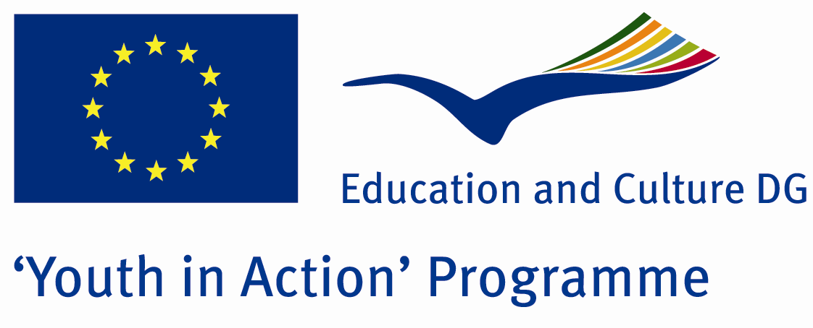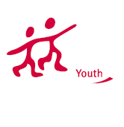

There is no obstacle, but society



ACTION 1.1 – Youth Exchange

11-18th August, 2011

Sinop, TURKEY

ACTION 1.1 Youth Exchange
11-18th August, 2011
Sinop, TURKEY

Please contact directly to;
adventurerpeacepigeons@gmail.com

Project Summary; The theme of this project is disabled people. In the society, there is not enough understanding for the disabled people. Everybody says that they support the rights of disabled people, but in the daily life they ignore the disabled people. Don’t care for their problems, don’t try to understand how different problems they would have and do almost nothing for them. The people generally realise this problem exactly when they are disabled or the people they know. With this project, we will take interest of more young people and the society, discuss and understand more about the problems of disabled people and ignorance of society. So if you find this theme important, we need your partnership!

Project Title; There is no obstacle, but society

Date and Venue ; 11-18th August, 2011 Sinop, Turkey .

Target Group ; Municipalities, City Councils and Non-Governmental organizations,
youth groups,culture and art groups,e.t.c

Participants ; 5 people from each country (over 18 -25 ). Totally 8 countries.

Conditions ; Accommodation, board and programme costs will be financed through European Commission Youth in Action Programme (Action 1.1). Travel costs will be reimbursed in 70% (APEX Tarrifs). Organizations from all 27 EU member countries plus Liechtenstein , Norway and Iceland are eligible to take part.

Working language: English

Organizer; Discovery And Adventure Group

How to apply: If you are interested, please send your Part III forms to
0090 216 483 21 67 by FAX please. (Fulfilled Part III which you can find in the attachment, of course signed and stamped) ..

Note: jpeg is not allowed..please send by fax…

Next step 2;
Original send via regular post to this address please:

Ertan DERİN
Öner İnşaat
Abdulhalik Renda Cd.
Parlar Sk. No:4 Pendik/İSTANBUL

If you have any questions you may contact with: adventurerpeacepigeons@gmail.com

Deadline for application; until 20th January 2011.

For Further information:
Contact Person
Ertan DERİN
Öner İnşaat
Abdulhalik Renda Cd.
Parlar Sk. No:4 Pendik/İSTANBUL

e-mail : adventurerpeacepigeons@gmail.com
Mobile : 0090 542 393 93 90
Fax : 0090 216 483 21 67

